An Overview

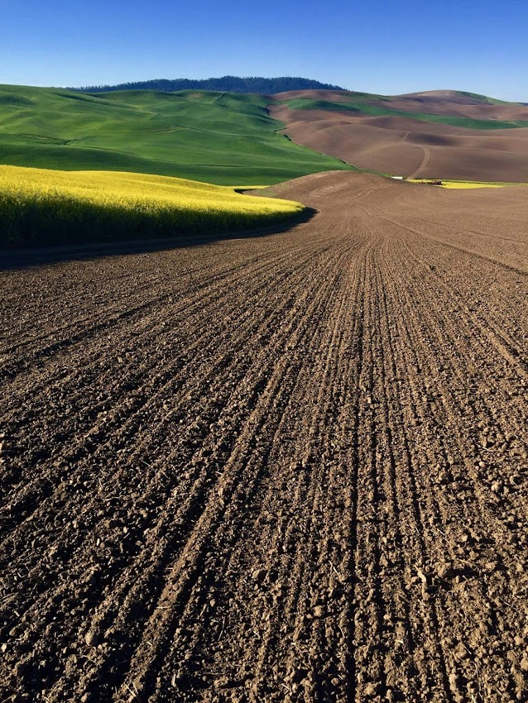 |  | Art  - Moscow Middle School  - Fall 2018  FALL 2018
Our home: the beautiful palouse | Artists Create Community
Artists can create connections to their community through art, but can also create community through art. This can be done in the making process by sharing common visions and making art together. This can also be done through the art itself by sharing it with the community.

What is art and what is our purpose as artists? How can we use our artistic abilities and curiosities about the world to create art that is both personally relevant and meaningful to our community and/or society? In this advanced art class, you are asked to call on your skills gained from previous art classes to create work that extends beyond the walls of the classroom. This might be in the form of the research or connections you make in the community, or a public art project that engages other members of our community through collaboration or education.
You will create art through a series of learning experiences and investigative projects. These
experiences and projects, though designed by Mrs. Norman, will allow you opportunity to search for answers to your own curiosities and personal inquiries through self- driven research.
You will create project themes generated through the lens of identity and/or social issues. Projects ask you to refine your art-making skills through personal goal setting as well as research and practice. Throughout each project and you will display your understanding in a variety of ways: written reflection, critique, one-on-one and class discussions, and project sharing. Your work will be assessed based on your self-chosen goals.
Artists (fill in the blank) …____________
____________________________________________________________________________________________________________________

Artists have a responsibility to recognize inequities and then create art in a way that addresses the need for social change.
Artists are Agents of Change
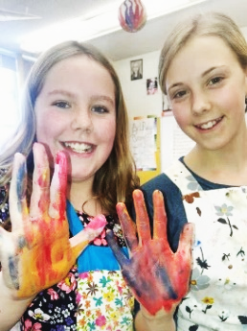
“Art no longer wants to respond to the excess of commodities and signs, but to a lack of connections.”
– Jaques Rancière
Expectations
You can count on me to:
- Provide you with inspiration to guide your learning goals.
- Provide you with guidance as to how to meet your learning goals.
- Provide you with (or guide you to) resources needed for your learning process.
- Treat you with respect, knowing that you are fully capable to make artistic discoveries on your own.
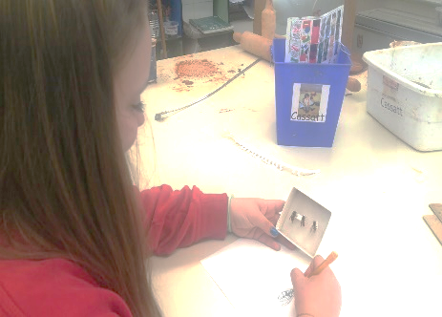
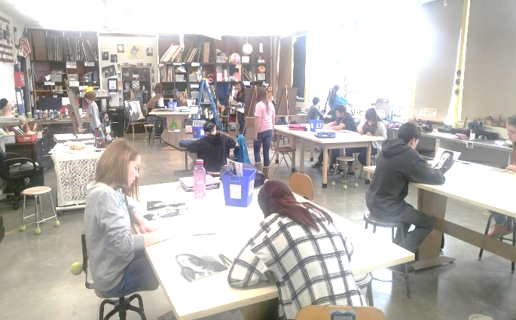
- Fill in the blank…_______
__________________________________________________________________
“Half the curriculum walks in the door when the students do.”
- Emily Style

You will hold yourself and your classmates accountable to:
- Think critically about issues that matter to you and others.
- Take risks, make mistakes, reflect and iterate.
- Fill in the blank…___________________________________________________________________________________________________________
- Act upon those issues through research, collaboration, experimentation and art making.

National Core Art Standards:
- Creating -Conceiving and developing new artistic ideas and work.
- Presenting - Interpreting and sharing artistic work.
- Responding - Understanding and evaluating how the arts convey meaning.
- Connecting - Relating artistic ideas and work with personal meaning and external context.

Course Content

“…learning is a creative process rather than transmission… “
Carlina Rinaldi

Heading 4 Style
Use the small tables provided in some of the articles to call out quick reference information related to the article, such as contact information or event dates.

Heading 5
Contact Info
Issues:
- Social
- Global
- Personally relevant
Identity:
- Introspective
- In relation to community

In each of the projects you will be drawing on elements from these three content areas

